# LAB 3 & 4

**Muhammad Azan Afzal**

**22I-1741**

**CY-B**

* **TASK 2:**

1. Does the DNS request packet indicate the use of any specific DNS record type (e.g., A, AAAA, MX)?

Yes, it contains A type.

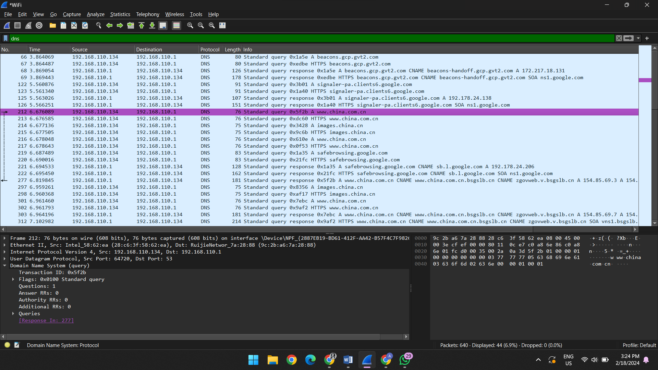

1. What is the domain name being queried in the DNS request packet?

Queries

www.china.com.cn: type A, class IN

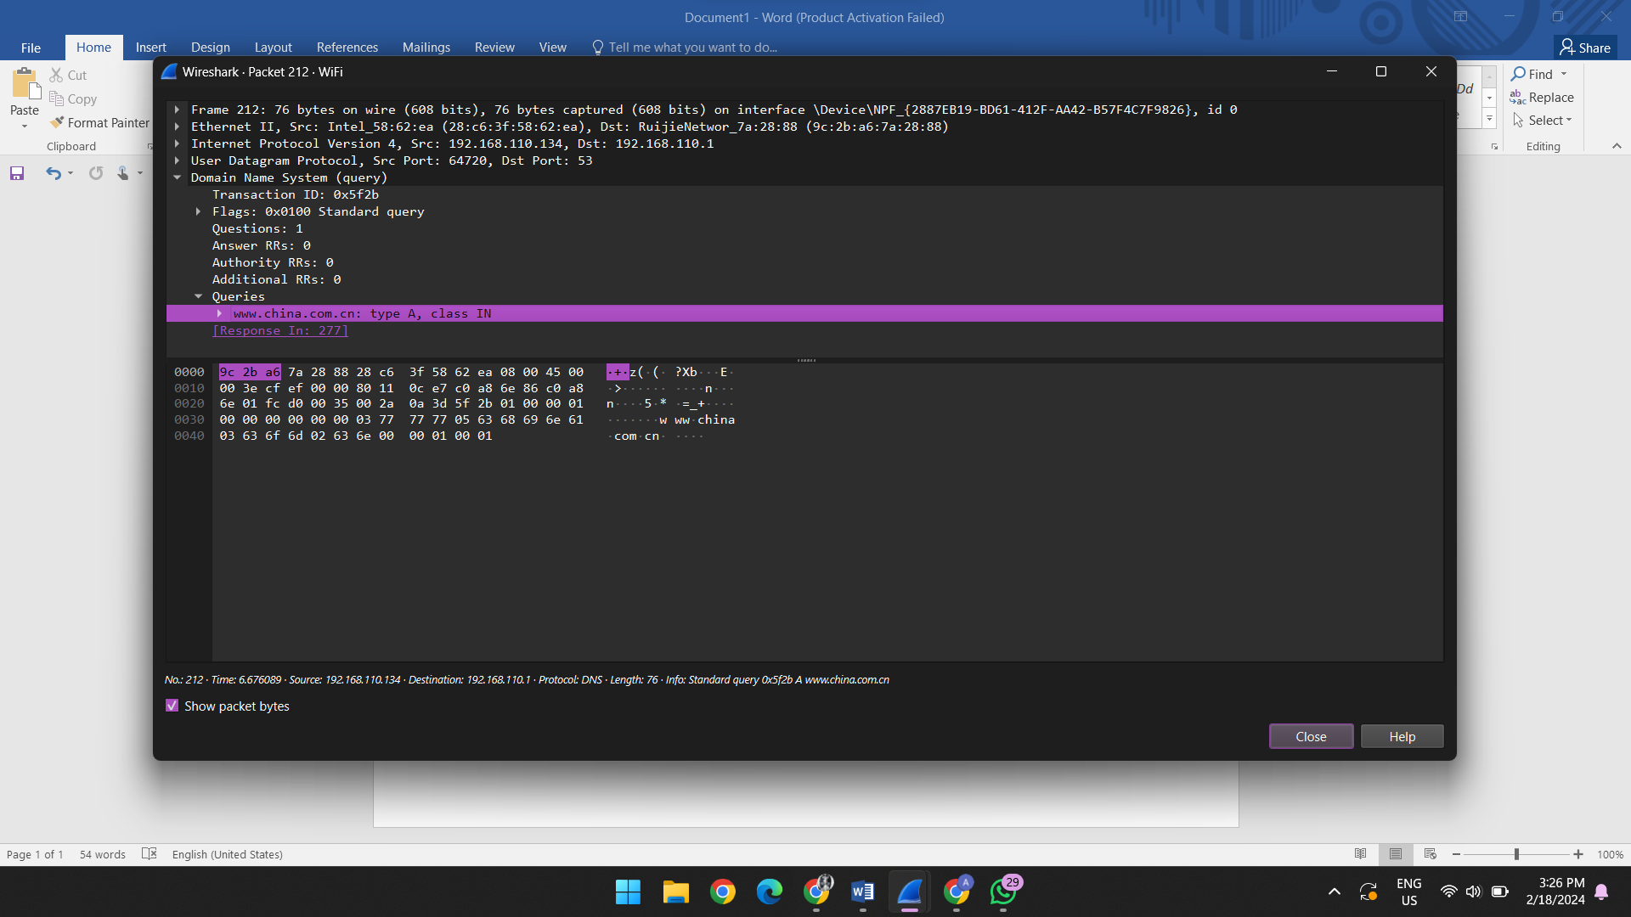

1. Is the DNS query using UDP or TCP as the transport protocol?

UDP

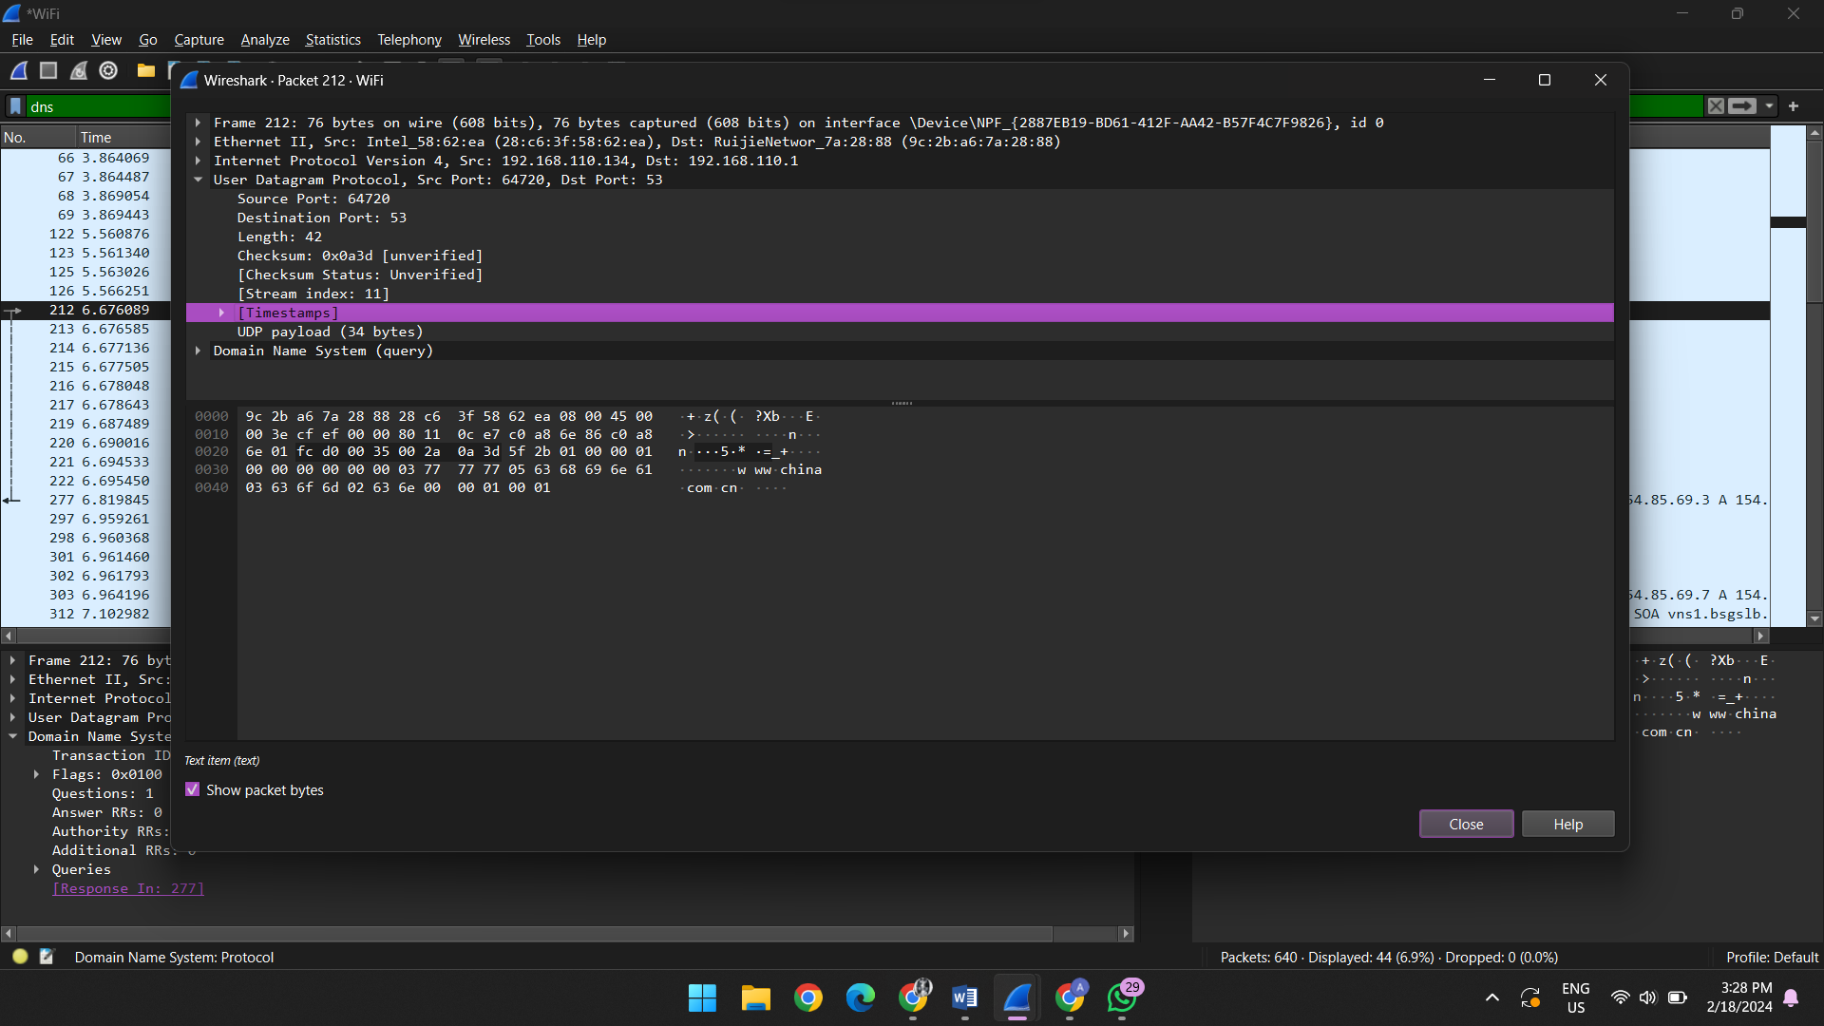

1. What is the IP address of the DNS server that provided the response?

192.168.110.1

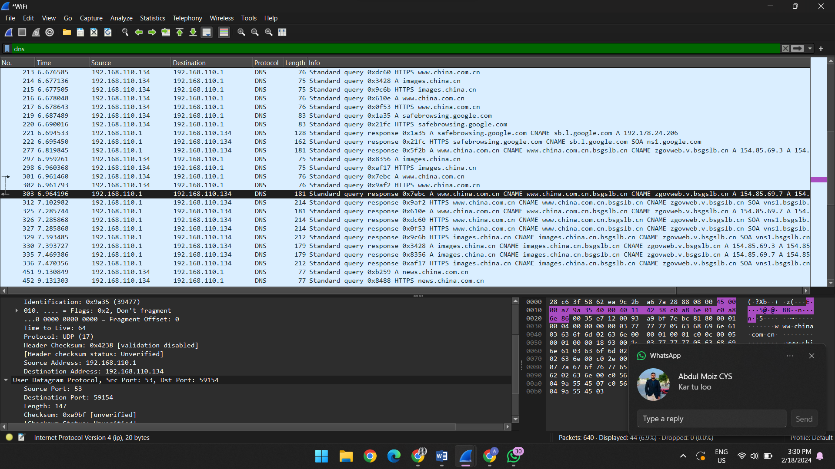

1. Does the DNS response packet include the requested IP address(es) for the queried domain?

Yes , it contains.

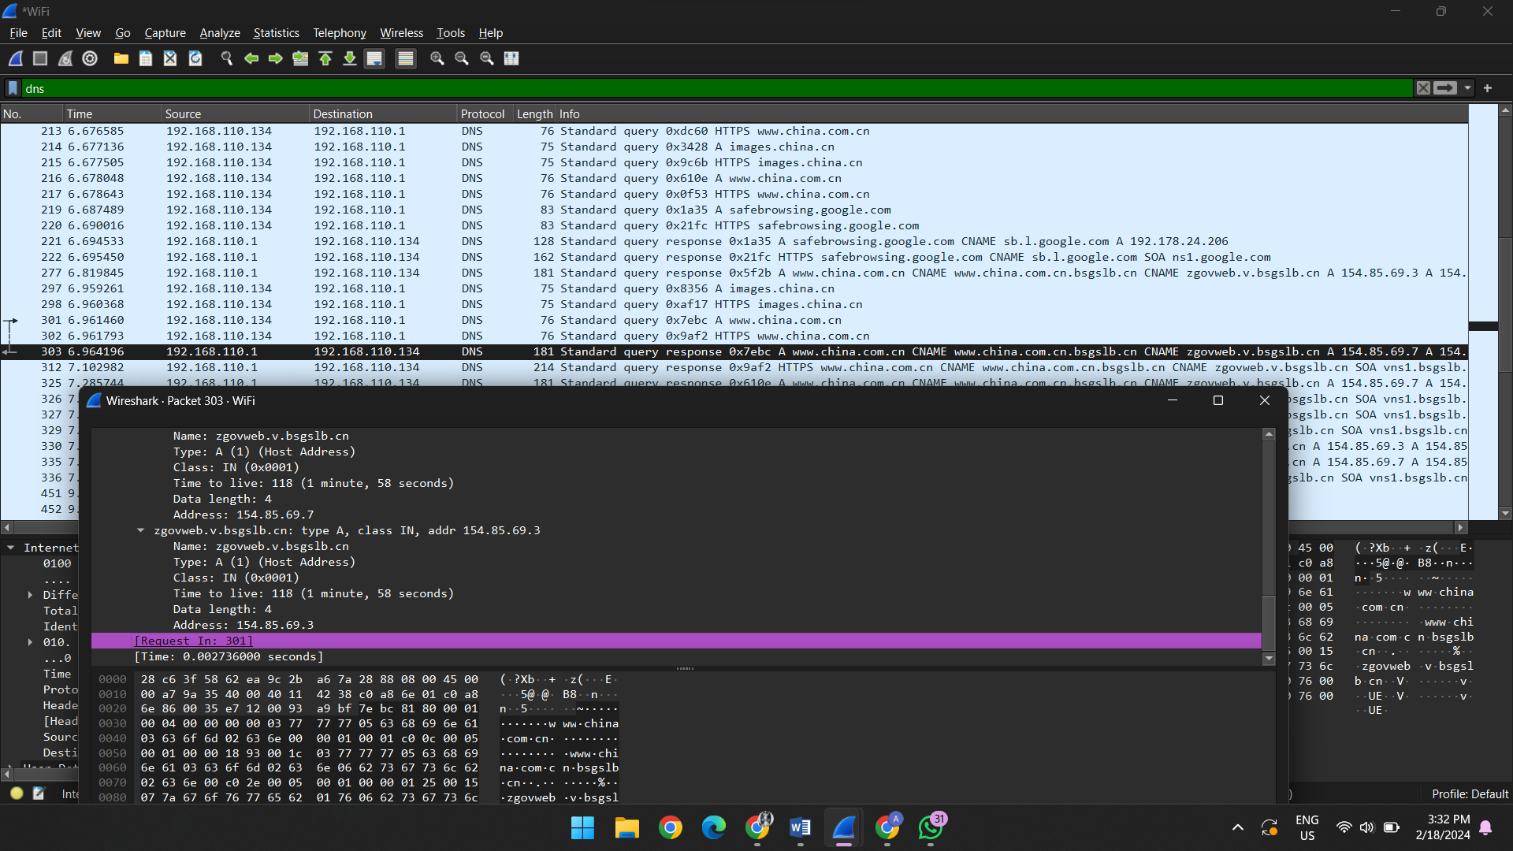

1. Do you observe any DNS packets with the "Truncated" flag set, indicating a truncated response?

No

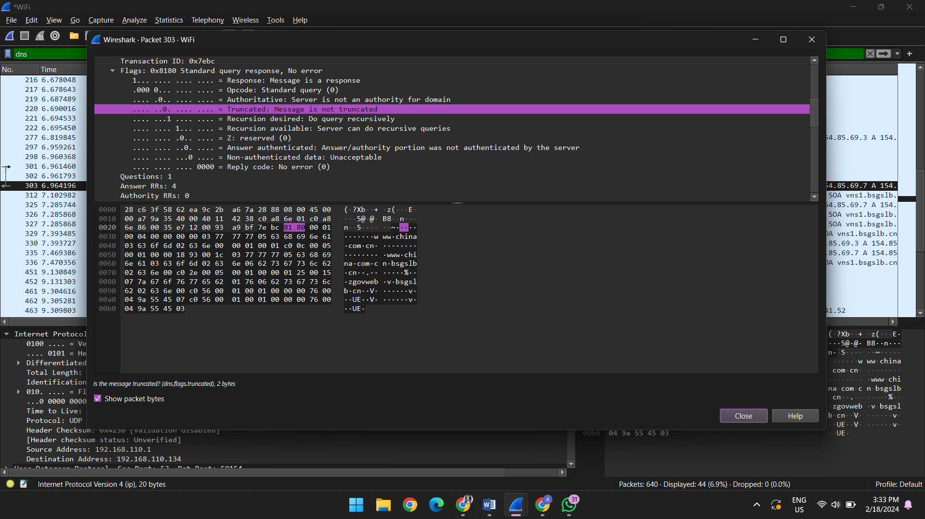

1. What is the Time-to-Live (TTL) value in the DNS response packet for the resolved IP address?

1 hour, 44 minutes, 51 seconds

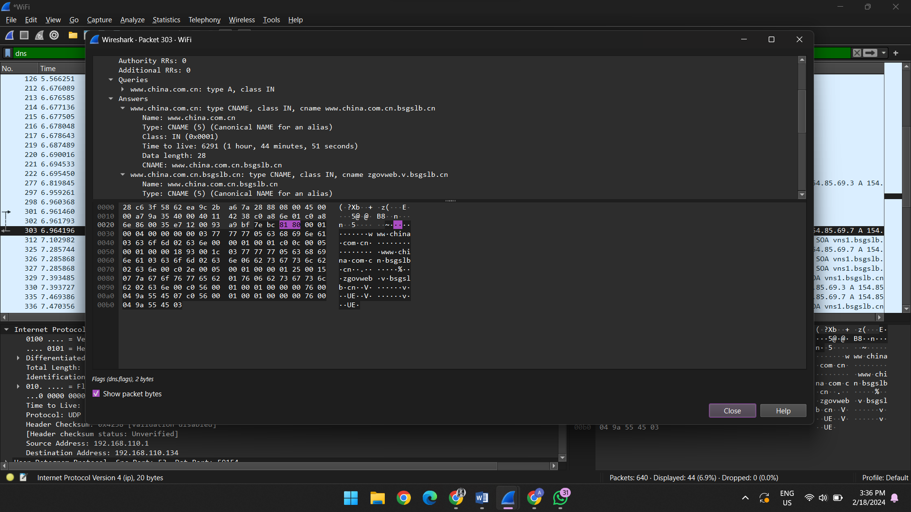

6. Are there any DNS response packets indicating that the queried domain does not exist (NXDOMAIN)?

No , there are not any packets.

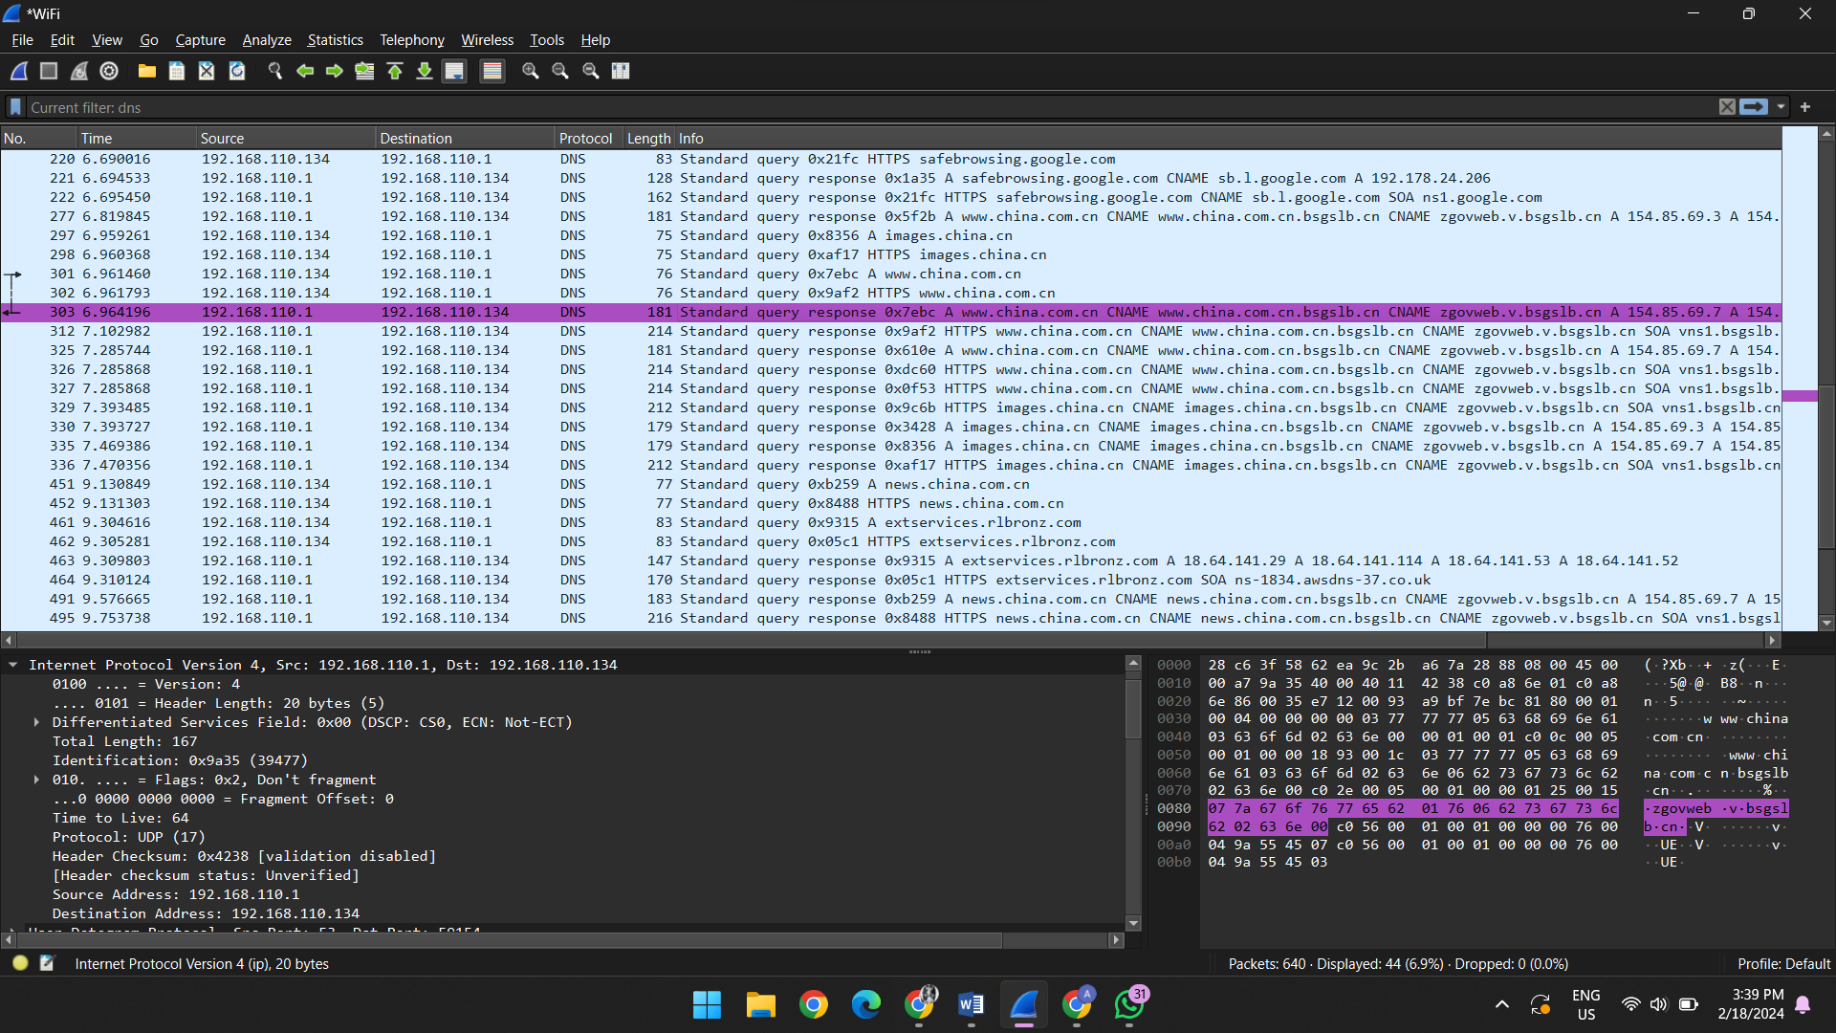

* **TASK 1:**

1. Is your browser running HTTP version 1.0 or 1.1?

1.1

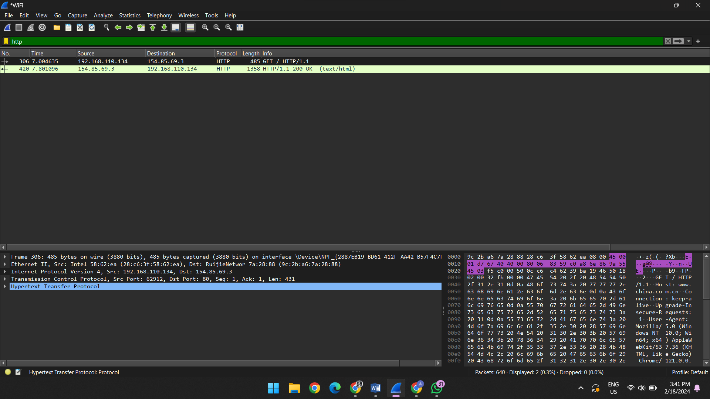

1. What languages (if any) does your browser indicate that it can accept to the server?

en-US, en:q=0.9\r\n

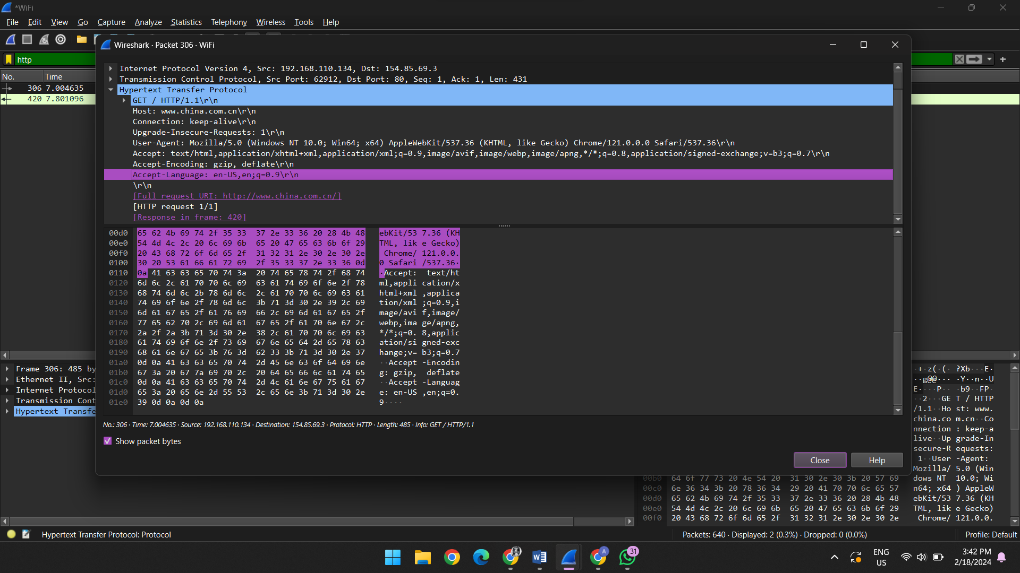

1. What is the IP address of your computer and the website?

WEBSITE IP = 192.168.110.134

COMPUTER = 154.85.69.3

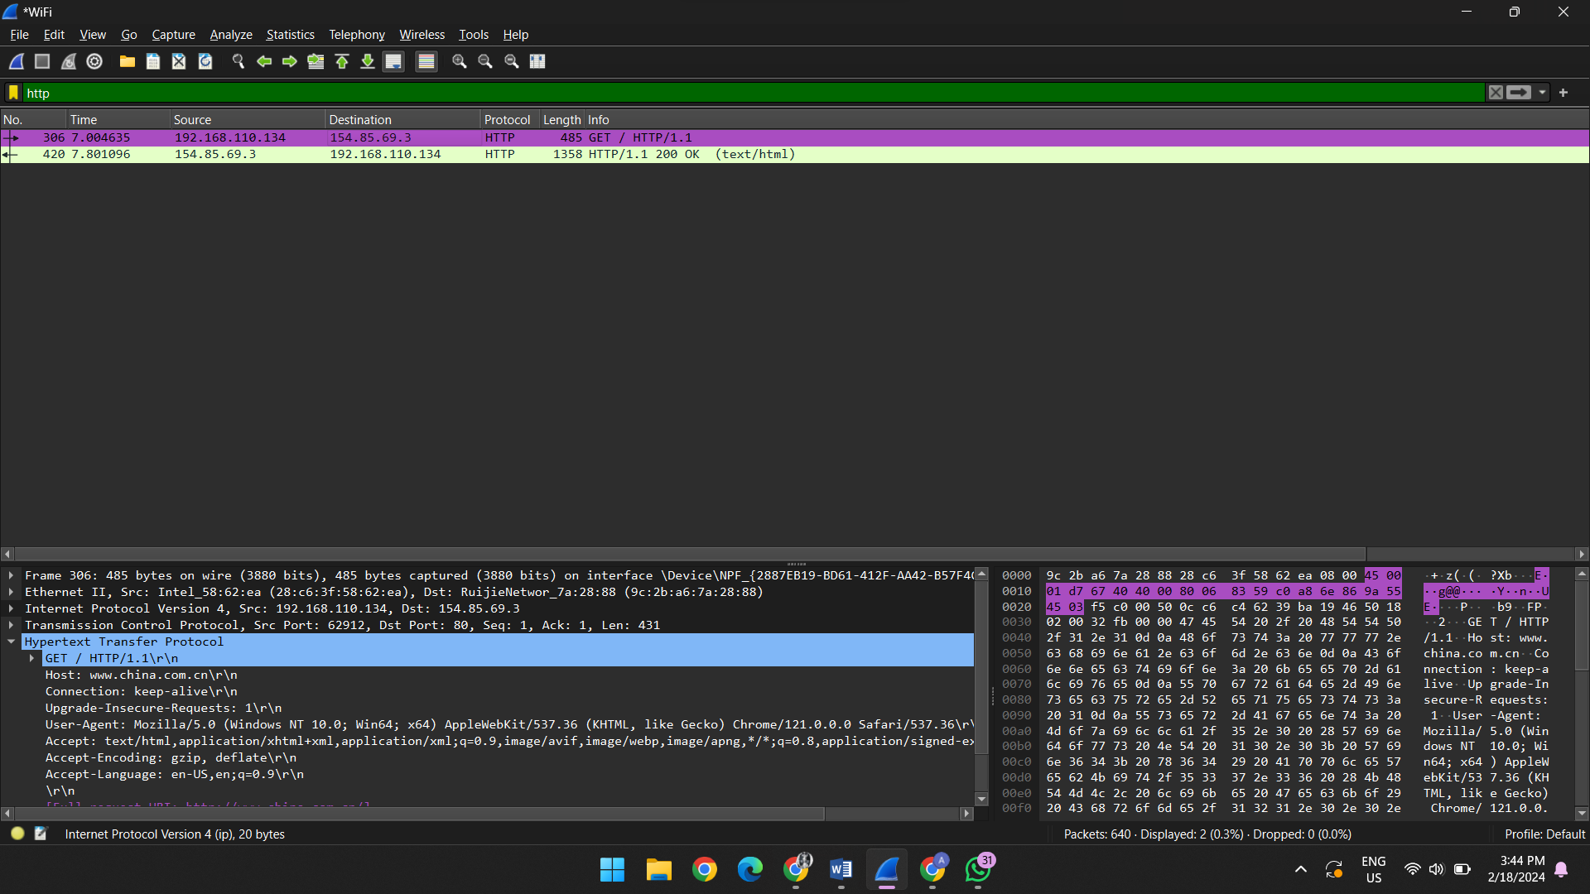

1. What is the status code returned from the server to your browser?

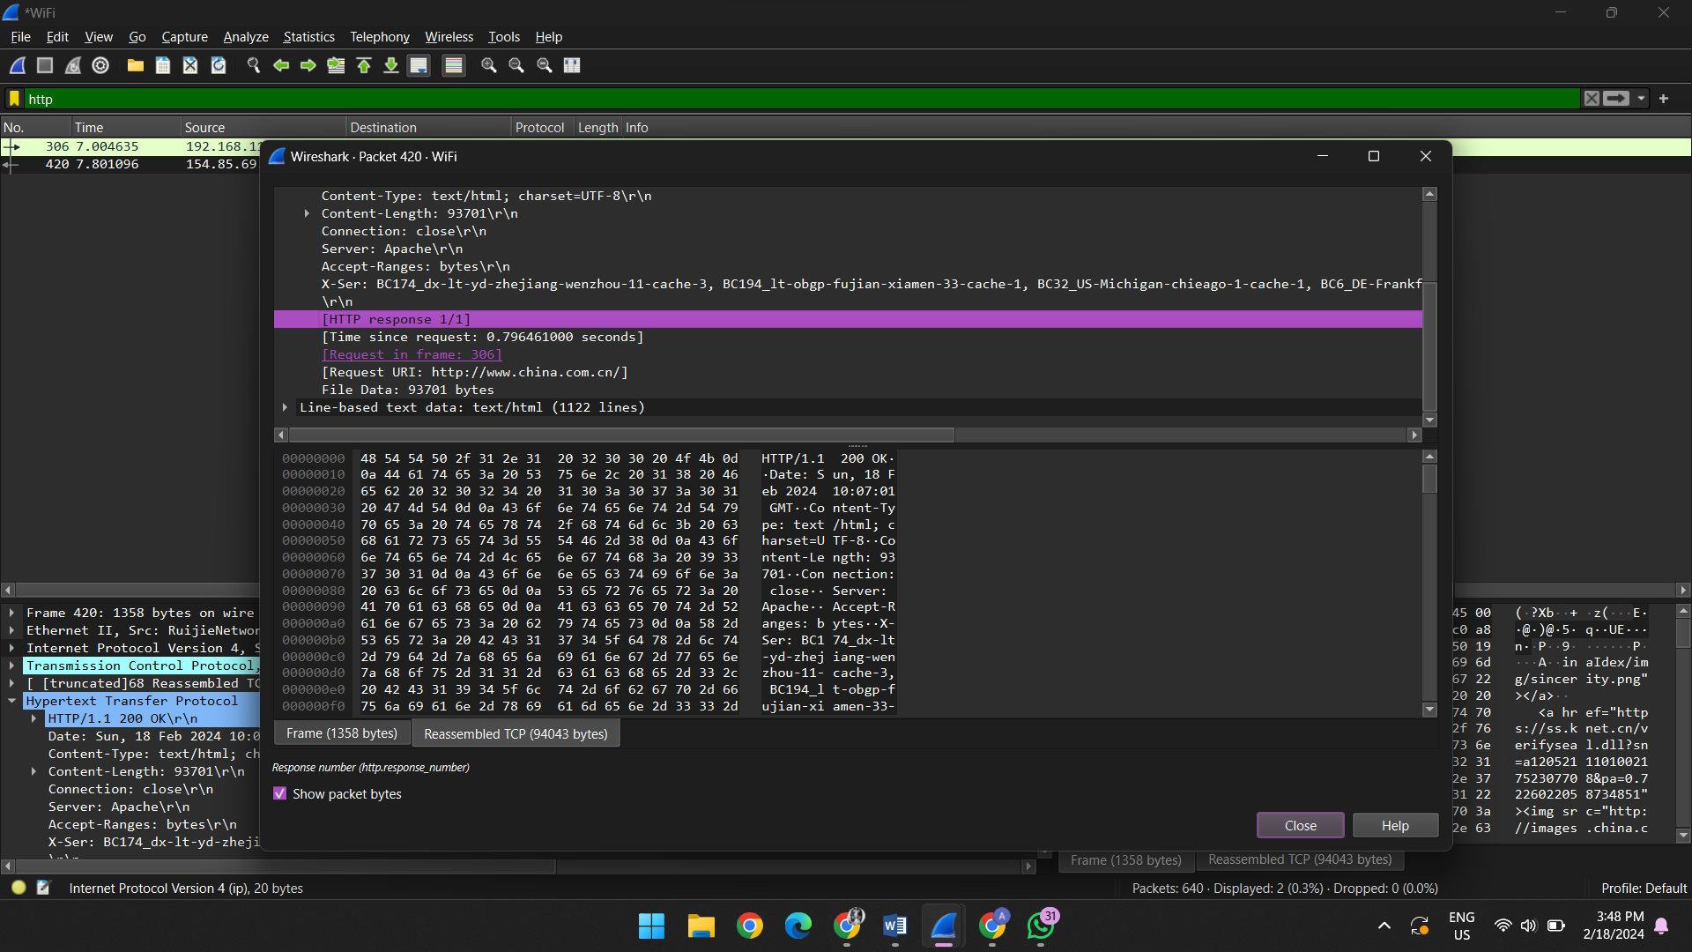

1. When was the HTML file that you are retrieving last modified at the server?
   1. SECONDS

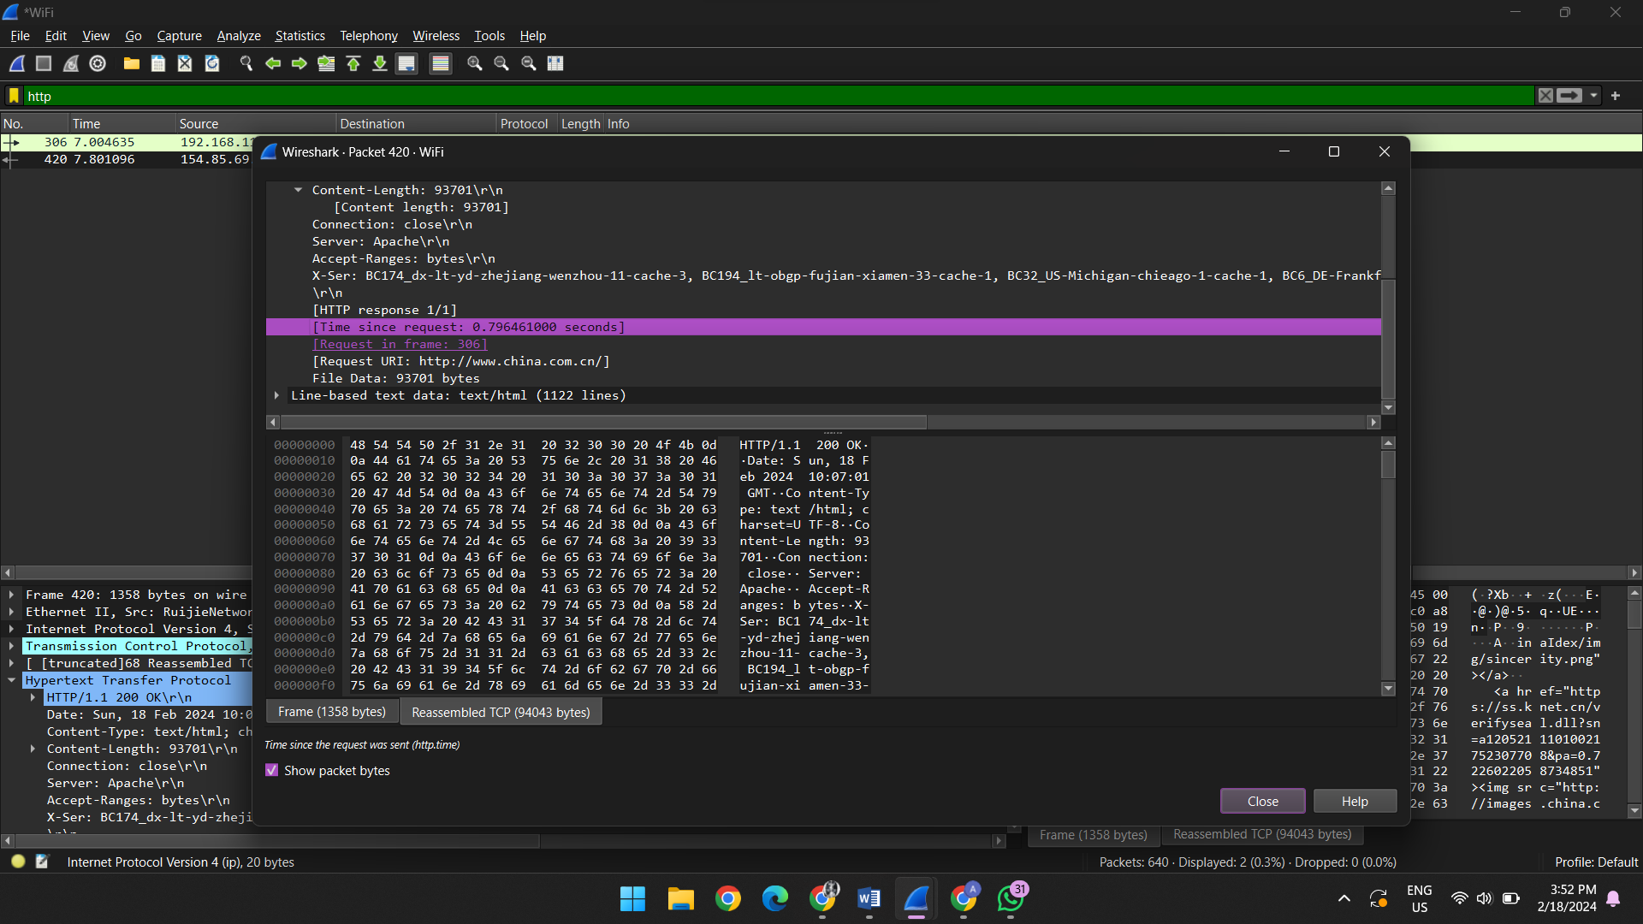

1. How many bytes of content are being returned to your browser?

93701

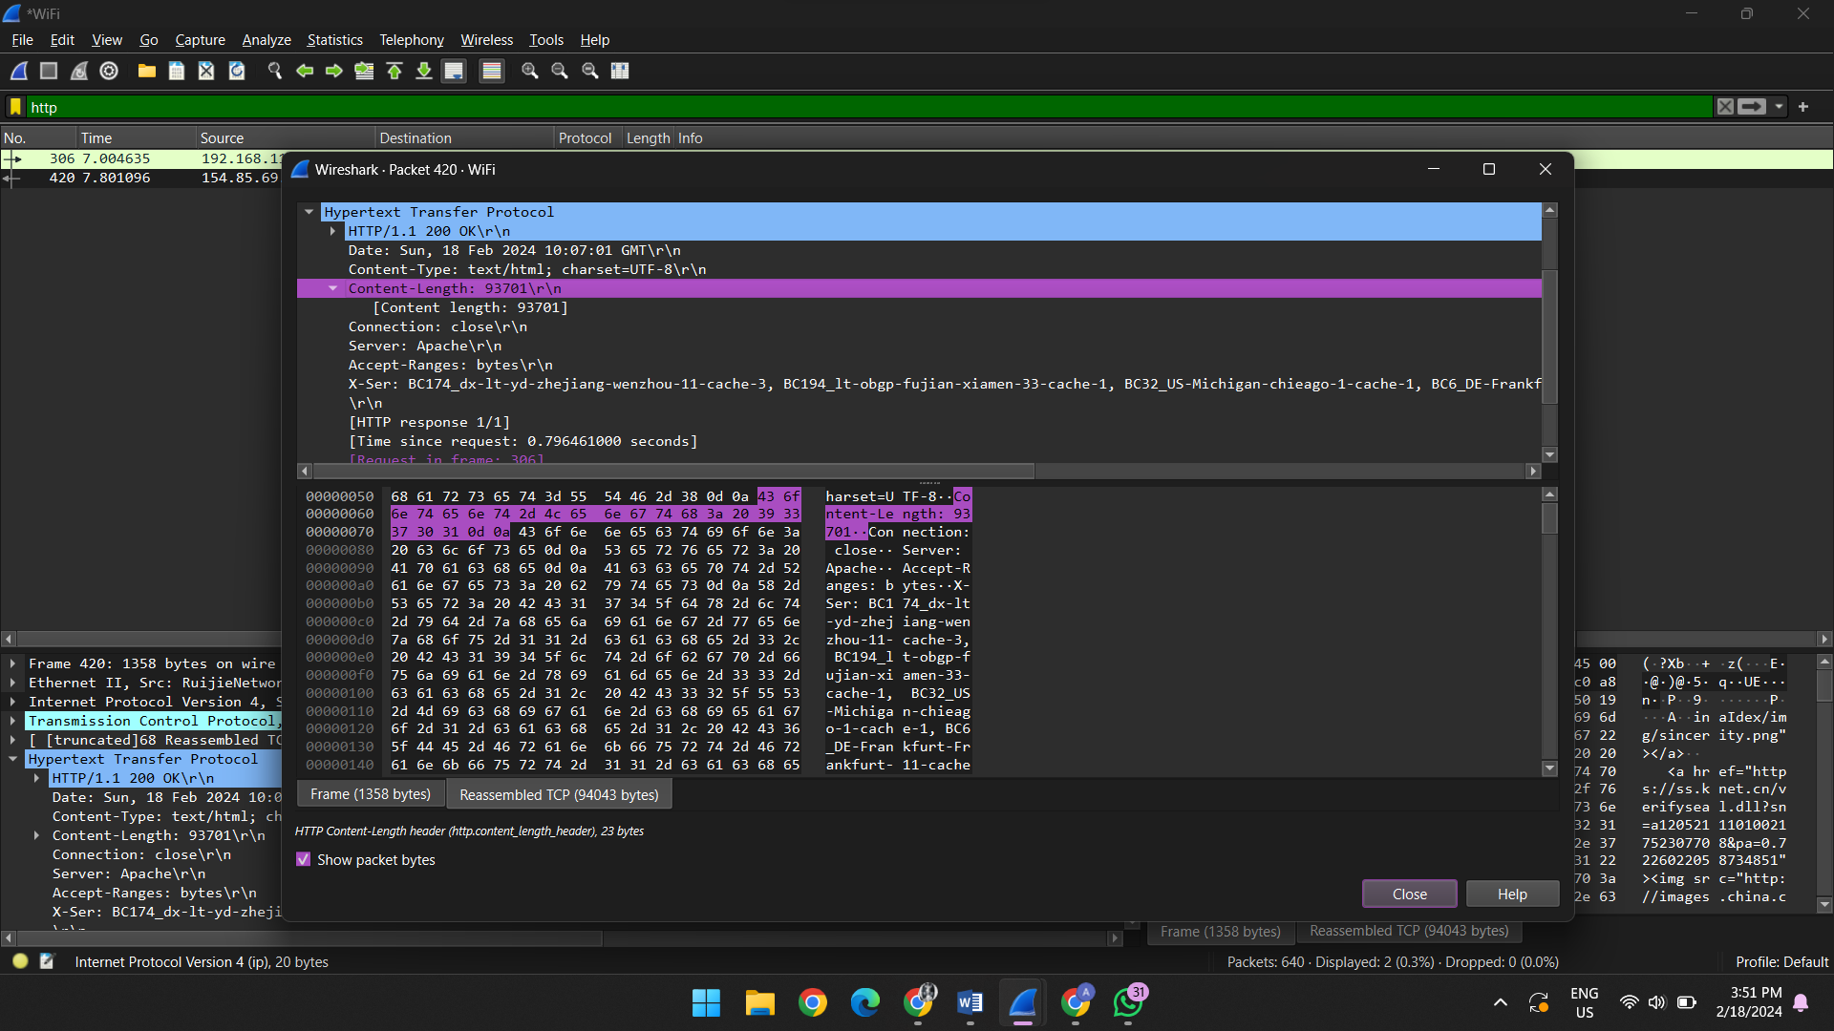

7. By inspecting the raw data in the packet content window, do you see any headers within the data that

are not displayed in the packet-listing window? If so, name one.

No

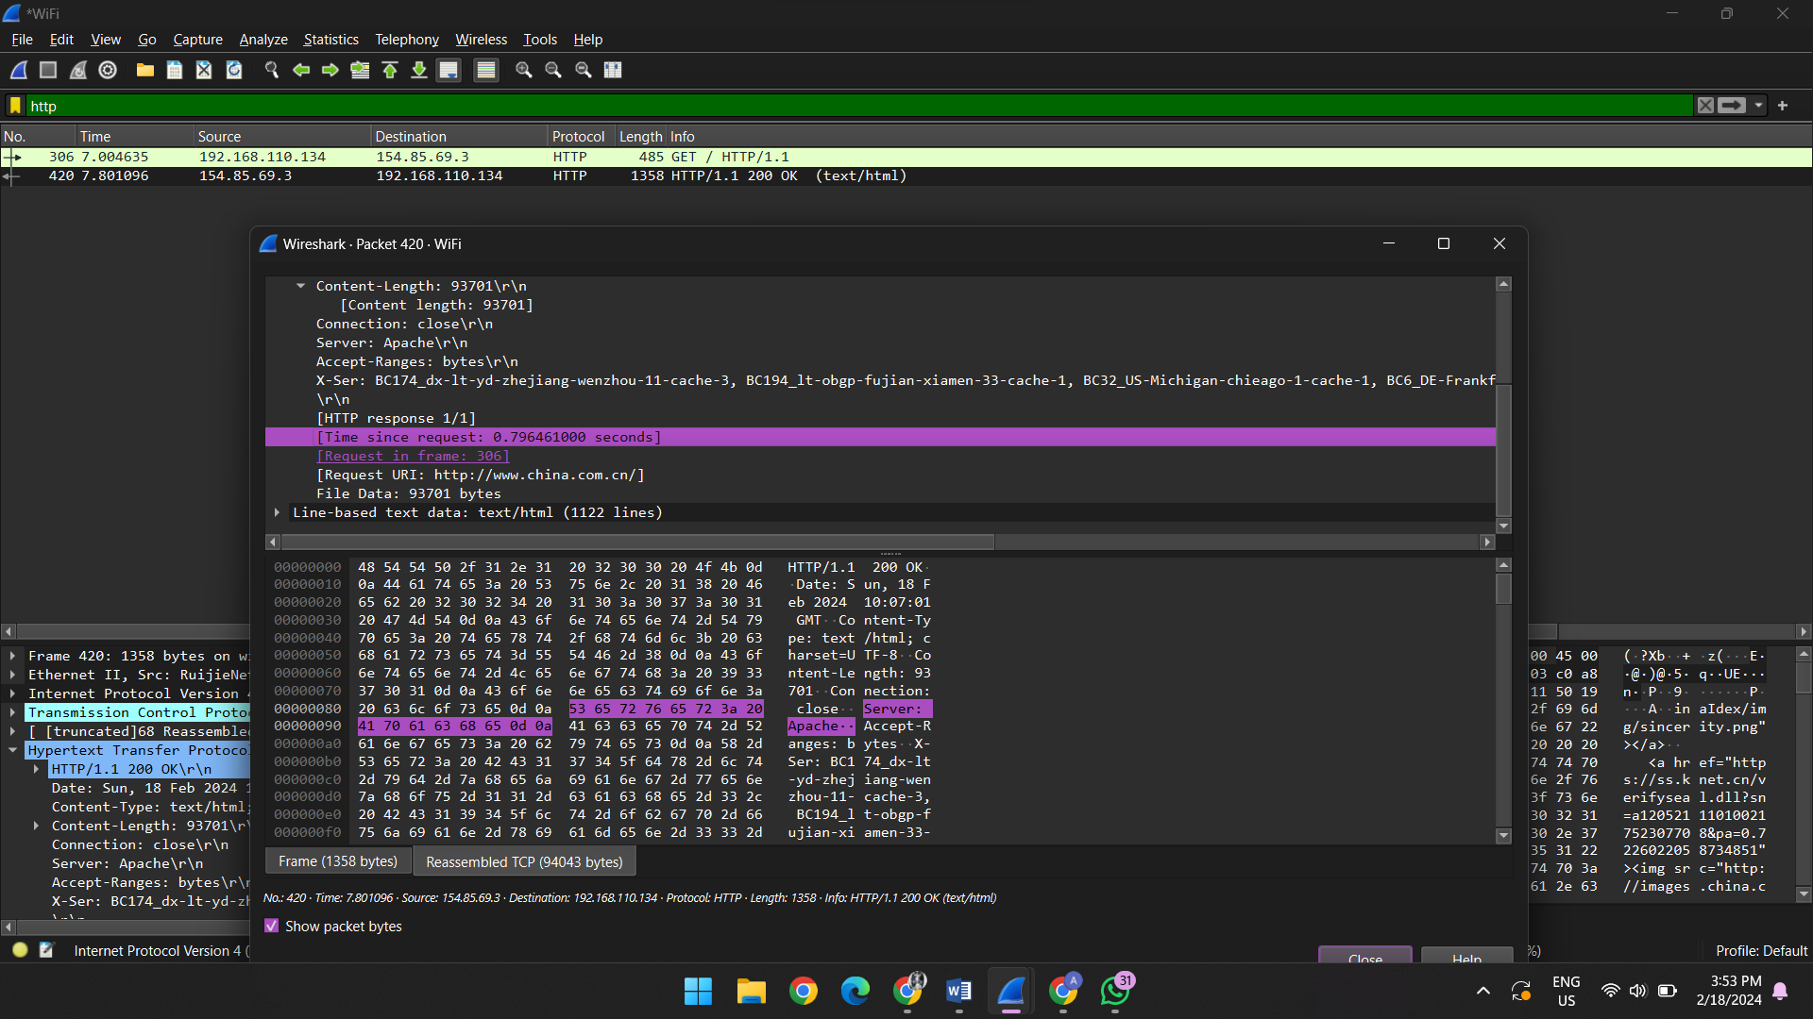

8. Which packet number in the trace contains the status code and phrase associated with the response

to the HTTP GET request?

306

